I2C 16X2 LCD
The classic parallel LCD consumes a lot of pins on the Arduino. Even in the 4-bit mode, it requires at least 6 digital I/O pins on the Arduino. So in many projects where you use the classic parallel LCD, you will run out of pins very easily.
The solution to this problem is to use an I2C LCD display. It requires only two digital I/O pins and you can even share those two pins with other I2C devices.

I2C LCD Overview
An I2C LCD display consists of a classic parallel LCD and an I2C LCD adapter. The I2C LCD adapter is soldered from the back of the LCD.
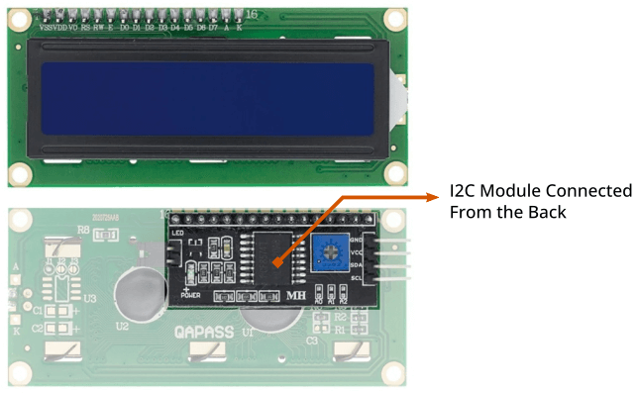
If you already have an LCD you can only purchase the I2C LCD adapter and solder it by yourself.

Liquid Crystal Display (LCD)
Commonly available LCD displays with I2C LCD adapters are 16×2 and 20×4 character LCD displays. They both have a total of 16 pins including 8 parallel data pins. So if you don’t use an I2C LCD you will need at least 6 digital I/O pins on the Arduino to display something.
If you look closely you will find that the characters of the LCD are built using a grid of 5×8 pixels.

I2C LCD Adapter Overview
At the center of this adapter, there is an 8-bit I/O expander chip – PCF8574. It takes the I2C data from the MCU (Arduino) and converts it into serial data required for an LCD display. On one side the I2C LCD adapter has four pins that can be connected to Arduino or any microcontroller that supports the I2C communication protocol. On another side, it has 16 pins that are connected to the LCD display.
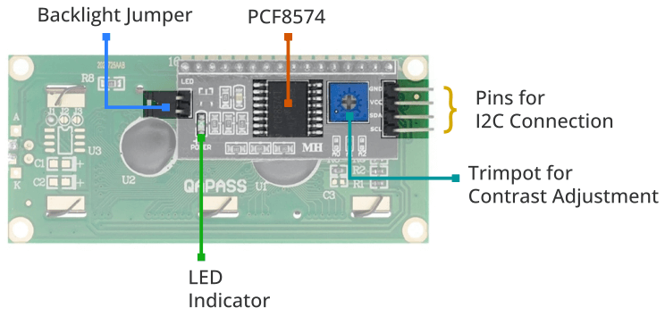
There are two header pins to control the backlight of the LCD display. One pin supplies a 5v power and another pin is for the backlight LED. These two pins are connected together by default. So the backlight will be always on. You can remove the jumper to turn off the backlight LED or you can use a potentiometer in between these two pins to control the intensity of the backlight LED.
The I2C LCD adapter also has a small trim pot to adjust the contrast of the display.

How to Change the Default I2C Address
Some I2C LCD adapters come with PCF8574, while others use PCF8574A chips. Each of these chips has its own I2C address. The PCF8574 chip from NXP Semiconductor uses 0x27 while the PCF8574A chip uses 0x3F.
Sometimes you need to change this default I2C address for a project where you use multiple I2C devices on the same I2C bus So that it does not conflict with other I2C devices.
If you use multiple I2C devices on the same I2C bus, sometimes you need to change this default I2C address to avoid conflict with other I2C devices.
To change the default address it has address selection pads – A0, A1, and A2.
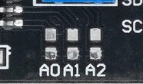
Each of these pads has a ground connection above it. By default, each of these pins is connected to VDD or a positive power supply. You can change the address by connecting any pin to the ground pin above it. You can make any possible combination and you will get a different address. From three address pins, you can get 2³ different combinations means 8 different addresses.
If you go through the datasheet of PCF8574 by NXP, you will find that PCF8574 and PCF8574A use a 7-bit I2C address. The first four-bit is fixed and the last three-bit is hardware selectable.
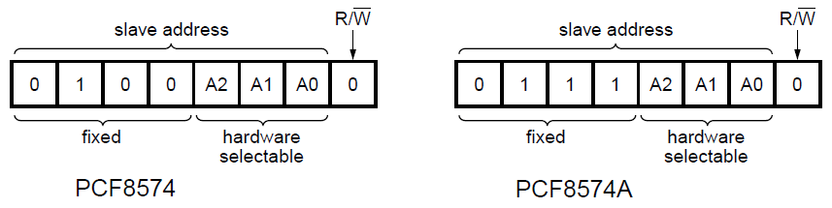
As you read above A0, A2, and A3 are connected to the positive power supply by default. So the default address of PCF8574 is 0100111 in binary or 0x27 in hex. If you connect the A0 pin to the ground pin it will become logic LOW. The address will change to 0100110 in binary or 0x26 in hex.
See the illustration below to find all the possible connections and the hex addresses.
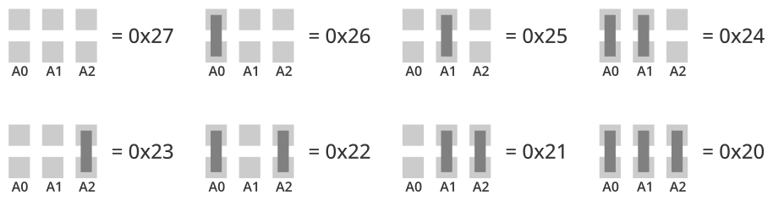
In the same way, you can change the address of a PCF8575A chip. But keep in mind that the first four bits of the PCF8575 are 0100 and the first four bits of the PCF8575A are 0111. Calculate the address according to it.

I2C LCD Pin-out
The I2C LCD display has four pins coming out from the I2C LCD adapter. These four pins are – Ground, VCC, SDA, and SCL.
You can see the pinout of an I2C LCD display in the image below.
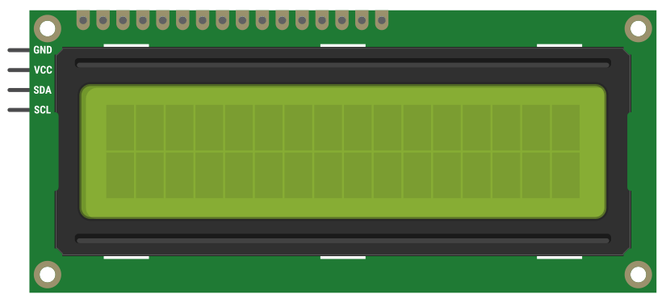

Wiring an I2C LCD Display to an ESP8266
Connecting I2C LCD to ESP8266 is very easy as you only need to connect 4 pins. Start by connecting the VCC pin to the VIN on the ESP8266 and GND to ground.
Now we are left with the pins which are used for I2C communication. We are going to use the default I2C pins (GPIO#4 and GPIO#5) of the ESP8266. Connect the SDA pin to the ESP8266’s D2 (GPIO#4) and the SCL pin to the ESP8266’s D1 (GPIO#5).
The following table lists the pin connections:
I2C LCD |  | ESP8266
VCC |  | VIN
GND |  | GND
SCL |  | D1
SDA |  | D2

Adjusting The LCD Contrast
After wiring up the LCD you’ll need to adjust the contrast of the display. On the I2C module you will find a potentiometer that you can rotate with a small screwdriver.
Plug in the ESP8266’s USB connector to power the LCD. You will see the backlight lit up. Now as you turn the knob on the potentiometer, you will start to see the first row of rectangles. If that happens, Congratulations! Your LCD is working fine.

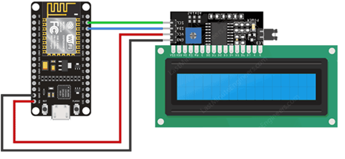
Once this is done, we can start programming the LCD.

Library Installation
To drive an I2C LCD you must first install a library called LiquidCrystal_I2C.
To install the library navigate to Sketch > Include Libraries > Manage Libraries… Wait for Library Manager to download the library index and update the list of installed libraries.
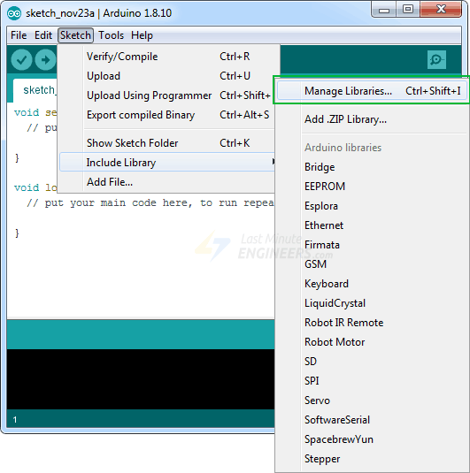
Filter your search by typing ‘liquidcrystal‘. There should be some entries. Look for the LiquidCrystal I2C library by Marco Schwartz. Click on that entry, and then select Install.
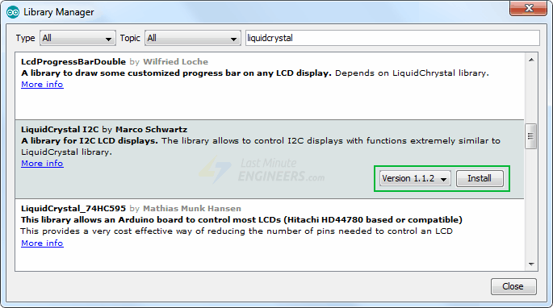

Basic Example Code – Hello World!
The following test sketch will print ‘Hello World!’ on the first line of the LCD and ‘LCD Tutorial’ on the second line.
But, before you proceed to upload the sketch, you need to make a small change to make it work for you. You must pass the I2C address of your LCD and the dimensions of the display to the constructor of the LiquidCrystal_I2C class. If you are using a 16×2 character LCD, pass the 16 and 2; If you’re using a 20×4 LCD, pass 20 and 4.
// enter the I2C address and the dimensions of your LCD here
LiquidCrystal_I2C lcd(0x3F, 16, 2);

Once you are done go ahead and give the sketch a try.
#include <LiquidCrystal_I2C.h>

LiquidCrystal_I2C lcd(0x3F,16,2); // set the LCD address to 0x3F for a 16 chars and 2 line display

void setup() {
lcd.init();
lcd.clear();
lcd.backlight(); // Make sure backlight is on

// Print a message on both lines of the LCD.
lcd.setCursor(2,0); //Set cursor to character 2 on line 0
lcd.print("Hello world!");

lcd.setCursor(2,1); //Move cursor to character 2 on line 1
lcd.print("LCD Tutorial");
}

void loop() {
}

